Smith, Paul (from University of Tasmania website)
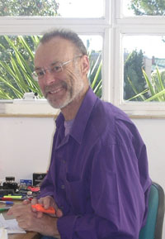
BSc Forestry from ANU 1965. MSc.
In 2013 a University Associate at School of Geography & Environmental Studies, University of Tasmania.
Worked in forest management from 1966 to 1990 for the Tasmanian government agency (and later, GBE) for forestry, except for a year’s secondment to the PNG Department of Forests in 1970. Most of this work was in planning - for both land use and the harvesting and growing of timber. Concurrently, I was also actively engaged in wilderness protection, both professionally and privately. In 1978-79 he played a major role in getting the Institute of Foresters of Australia to develop a policy on wilderness.

Current membership:
The Wilderness Society (founding and life member)
Sustainable Population Australia
Tasmanian National Parks Association
Environment Tasmania (member of the management committee, for 2012 and 2013)

